Spring 2017
TTH 1:30-3:20, BAG 261
Instructor: Eva Cherniavsky

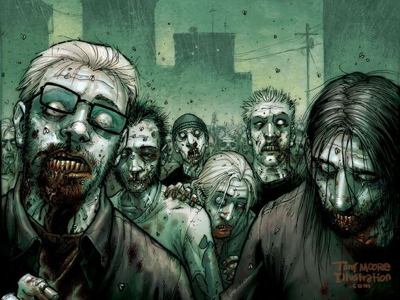

English 204A (Popular Fiction and Media)
Topic: “The Zombie Apocalypse”

Contemporary culture teems with the animated dead. While vampires have proliferated in fiction, film, comics and television for well over a century now, zombies are more recent arrivals; the emergence of zombie narrative as a new, cross-media genre of popular culture is usually dated to George Romero’s iconic 1978 film, Dawn of the Dead. If vampires are a late-19th-century phenomenon (Bram Stoker published Dracula in 1897), zombies are late-20th-century and early-21st-century creatures. If vampires are ancient revenants (figures from earlier ages, called forth from the crypt), zombies are us – or, as Rick Grimes puts in Robert Kirkman’s comic, “We are the walking dead.”

This course will consider what it is that drives the attraction to the figure of the zombie, and what ideas about government, society, belonging, ecology, and futurity zombie narratives explore. Dracula’s arrival in Victorian London spoke to the effects of urbanization, industrialization, and colonialism: what might zombies have to tell us about de-industrialization, globalization, austerity, and the information age? While our focus will be on print fiction, we will also consider a number of films, as well as a television series.

Likely print materials include Richard Matheson, I Am Legend, Robert Kirkman, The Walking Dead Omnibus (volume 1), Colson Whitehead, Zone One, Tananarive Due and Steven Barnes, Devil’s Wake, and short fiction by Mira Grant. We will sample broadly from visual media, as well, probably including film adaptations of I Am Legend (The Last Man on Earth; Omega Man), Romero’s Dawn, as well as World War Z, Zombieland, Shaun of the Dead, and episodes of iZombie. Interested students are welcome to contact me closer to the start of the term for an updated list of course materials. Written work for the course will likely include two essays, a midterm, and a final exam.

