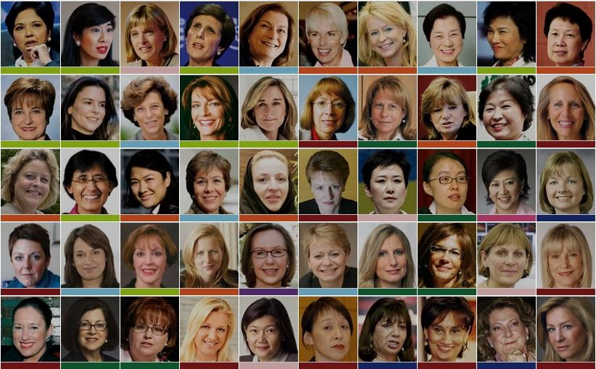

MGMT 490A – Spring 2017 – M W 1:30-3:20

**Women in Leadership**

What do the fabulous females above have in common? They are remarkable leaders and role models in business and the world . All have had to find their own most authentic and powerful leadership style - addressing questions of life purpose, jungle-gym careers involving family priorities, finding a source of passion and energy, taking the right risks, and building confidence on their road to success.

We will use their lives and the experiences of local guest speakers to find personal answers to the same questions, enhance skills and create a personal vision. We will:

* Interact with at least seven local women in leadership positions.**\***
* Apply a leadership framework that has helped women around the world succeed
* Build your appetite and comfort with the risk-taking that will help you excel
* Create a personal vision board to picture your ideal career and life
* Examine different ideas of work-life balance
* Practice your authentic leadership style to hone your most powerful voice and presence
* Translate your strengths, values, dreams and goals into a life and career worthy of you

**Professor: Cate Goethals** is a longtime Foster School lecturer and leadership development consultant whose MBA class “Women at the Top” was named one of the 10 most innovative MBA classes in the country by *Forbes.* Passionate about helping women to rise in their chosen fields AND lead satisfying lives, Cate directs multiple programs inspiring them to succeed and lead. Cate leads women’s leadership tours to India (next one for undergrads in Autumn 2017), coaches female executives on voice and presence, and directs the UW Foster Women Board Director Development Program. **Questions? Email Cate -** [**categ@uw.edu**](mailto:categ@uw.edu) **The class SLN is 16954 Special Topics in Management. Classroom: Paccar 394.**

***\*****These include two CEOs, a successful entrepreneur, co-founders of a business that grooms women leaders, a manager whose husband stays home with the children, and an author. You will also have the opportunity to contact and personally interview another leader you admire.*