MONKEY CAGE

For Democrats, trying to slow climate change is good politics

Our research suggests that co-sponsoring the Green New Deal helped in the 2020 elections. Could it boost incumbents’ votes in the 2022 midterms as well?
Analysis by Meagan Carmack, Nives Dolšak, and Aseem Prakash

July 15, 2022 at 6:00 a.m. EDT

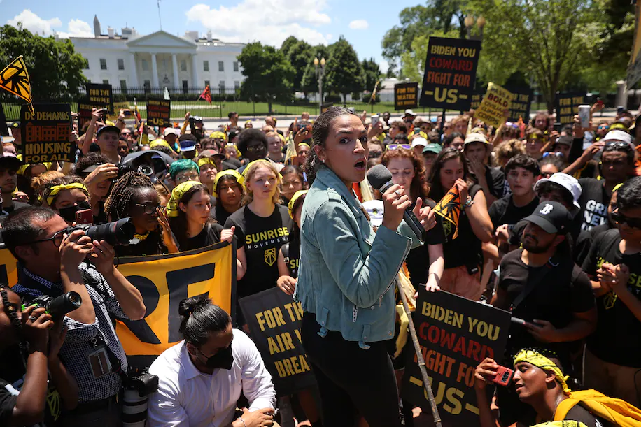

Rep. Alexandria Ocasio-Cortez (D-N.Y.) rallies hundreds of young climate activists in Lafayette Square near the White House to demand that President Biden work to make the Green New Deal law in 2021. (Chip Somodevilla/Getty Images)
Listen
6 min
Comment
0
Gift Article
Share
In its recent decision in West Virginia v. EPA, the Supreme Court ruled that without explicit congressional authorization, the Environmental Protection Agency (EPA) cannot compel power plants to stop using coal.

The court relied on the controversial major questions doctrine, which holds that the democratically elected Congress, not federal agencies, must decide issues that have major implications for the economy.

So, will Congress amend the Clean Air Act to explicitly authorize the EPA to regulate power plants? That depends in no small part on whether they believe that’s what voters want them to do.

Opinion polls suggest that, overall, Americans favor federal climate laws. But does that translate into votes? We looked into whether American voters will cast ballots for politicians who want new climate legislation — and found that Democrats who endorsed the Green New Deal (GND) resolution in Congress got a higher share of votes in the next election than their colleagues who did not.

What is the Green New Deal?

After the 2007-2009 recession, economist Edward Barbier introduced the concept of a “Green New Deal.” A decade later, Rep. Alexandria Ocasio-Cortez (D-N.Y.) and Sen. Edward J. Markey (D-Mass.) introduced that as a policy proposal, the Green New Deal resolution, House Resolution 109, and closely related Senate Resolution 59, in February 2019.

The Green New Deal outlined a comprehensive plan for how the United States could shift from carbon-based fuels to renewable energy sources in a way that promoted “justice and equity” in “front-line and vulnerable communities,” according to the text. The plan included limiting carbon emissions, supporting renewable energy, subsidizing electric cars and much more, aiming to do so in ways that would benefit the historically underprivileged.

In the House, 102 of 232 Democrats endorsed the resolution. No Republican did, in keeping with the Fox News framing of the bill as “socialist,” since it would give the federal government a sweeping role in the economy.

Climate issues and the voting booth

Similar plans have been proposed in several countries, and one was adopted in the European Union. Over the past several years, worldwide mobilization on climate issues has increased. That includes mass student climate strikes under the banner of Fridays for the Future, organized by Greta Thunberg, although those have been interrupted by the pandemic.

Similarly, until the pandemic, climate issues had begun to dominate the annual World Economic Forum meetings in Davos. Even since the pandemic, however, a number of leading companies, including oil and gas companies, have pledged to pursue zero-emission targets. Some stock market luminaries, such as BlackRock CEO Larry Fink, have become outspoken climate advocates.

Green parties with an explicit climate agenda performed exceptionally well in the 2019 Swiss federal election, winning more than 20 percent of votes. Campaigning for another term this year as French president, Emmanuel Macron promised to become an environmental president, as did Gustavo Petro, the newly elected Colombian president. In Brazil, protecting the Amazon is a major issue in the forthcoming presidential elections.

The United States generally lags behind its industrialized peers on climate action, with a strong lobby opposing any moves away from carbon-based fuels. The country did not ratify the 1998 Kyoto Protocol, which committed countries to reduce greenhouse gas emissions, and does not have a federal carbon tax or cap-and-trade policy, unlike most industrialized countries, including those in the European Union. In 2017, President Donald Trump withdrew the United States from the 2015 Paris agreement.

And yet opinion polls suggest that a bipartisan majority of Americans support climate action. We investigated whether voters reward candidates who support climate policy.

GND endorsements and 2020 congressional elections

Based on congressional records, we examined how co-sponsoring the Green New Deal resolution affected House members as they sought reelection in 2020. We focused on only 386 House seats, because in the remaining 49 House seats the incumbent retired, was defeated in the primaries, died, or resigned. We then compared those Democrats’ share of the vote in the 2020 election with those of Democrats who did not co-sponsor the resolution.

Because some voters tend to repeatedly vote for specific political parties, our statistical analysis took into account the candidates’ share of the vote in the 2018 elections. Our analysis also accounted for differences in the districts, such as voters’ average income, profession or race. Thus, by accounting for confounding factors, we were able to singularly focus on whether Green New Deal co-sponsorship is associated with House candidates’ vote share.

We found that Democrats who co-sponsored the Green New Deal resolution had a 2.1 percentage point higher vote share than those who did not.

Further, that co-sponsorship helped incumbents more than other ways they might have tried to assure voters that they cared about the environment. For example, we checked to see whether being endorsed by the Sierra Club, a leading U.S. environmental group, or having high League of Conservation Voters (LCV) scores, affected their votes. Neither were associated with candidates’ vote shares. This probably means that Democratic voters perceive climate change as something different from other environmental concerns.

Further, the Republican campaign against the GND might have helped those Democrats. Neither the Sierra Club’s endorsement nor the LCV score brought controversy or publicity. Voters may therefore have been more likely to know about the Green New Deal co-sponsorship, making it a more credible climate policy credential.

Given the many concerns this year — gas prices and inflation, abortion laws, voter disappointment in President Biden — it’s hard to know whether climate policy will surface in the midterm elections. But if it does, candidates may wish to consider how they communicate their positions to potential voters.

Meagan Carmack is a PhD student in political science and a graduate fellow at the Center for Environmental Politics, University of Washington, Seattle.

Nives Dolšak is a professor in sustainability science and director of the School of Marine and Environmental Affairs, University of Washington Seattle.

Aseem Prakash is a professor in the College of Arts and Sciences and founding director, UW Center for Environmental Politics, University of Washington, Seattle.

