Something Special for the Summer!
Summer Course to Unique Quebec -June 13-20, 2017

Comparative Urban Planning and Urban Design: Quebec, Canada and the U.S.

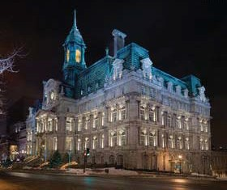
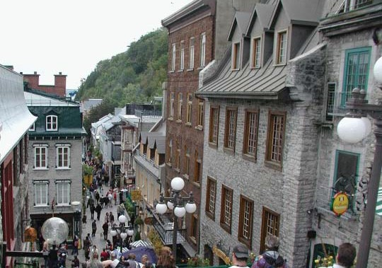
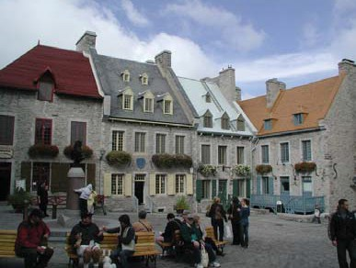
L Arch 495 --- 3 to 6 credits
w/URBDP 498C
w/URBDP 598C Canada Field Studies
Open to Juniors, Seniors, and Grad Students
If at all possible, please register by May 15, 2017
The course will examine similarities and differences between U.S. and Quebec cities. We will look more particularly at current urban issues confronting communities in Canada. We will study the physical layout of cities, urban design, and urban growth, problems related to the environment, governmental institutions as well as historical, social and cultural factors specific to Quebec cities. Students will write a paper on a topic related to urban issues encountered in Canada. Cities to be visited are Montreal and Quebec City.

The estimated cost of the trip is $1,200.
$200 scholarships are available for first 10 students. Students pay $100 for Global Affairs support, airfare, meals, lodging and ground transportation in addition to tuition. Personal items are your responsibility.

For further information, contact Professor
Wagner 206-351-6749. To register contact Diana Siembor
in UDP or JoAnne Edwards in Landscape Architecture.

